
Company
Logotype

Cone Beam Computed Tomography- Report



Porur Dental X-rays & CBCT

Patient Name : Miss. Maya Maragatham | Date of Report : 13.04.2025
Age/ Gender : 15 years/ Female | Region of Interest : CBCT Full Skull
Referring doctor: Dr. M. Balamurali Sai | Indication : Impacted tooth 13 and its orthodontic retrieval.
Clinical Notes: Nil
PATIENT INFORMATION

CBCT Full Skull provided
CBCT – IMAGE DETAILS

RADIOGRAPHIC INTERPRETATION

- Deciduous teeth present in the maxillary arch: 53.
- The tooth 13 appears to be within the alveolar bone, distally tipped with its crown in contact with the radicular portion of 12, 53 and root of 13 in contact with the medial wall of right maxillary sinus and floor of nasal cavity.
- The tooth 13 is positioned such that it involves the labial cortical bone.
- In relation to 16, 26, presence of hyperdense restorative material involving the crown and extending upto the apical third of their roots is evident.
- Presence of hyperdense orthodontic appliance evident in relation to maxillary teeth.
- The maxillary and mandibular alveolar ridge are present with normal trabecular pattern.

RADIOGRAPHIC IMPRESSION


- Impacted tooth: 13
- Retained deciduous tooth: 53.
- Orthodontic appliance- maxillary arch.
- Root canal treated teeth: 16, 26.

IMAGES FOR REFERENCE

RECONSTRUCTED PANORAMIC VIEW

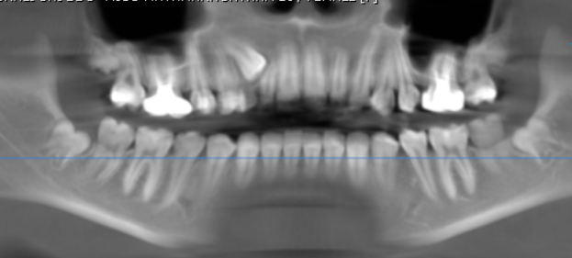

3-DIMENSIONAL VIEW

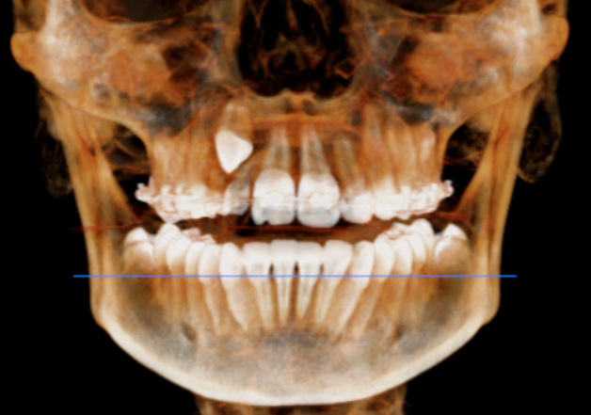

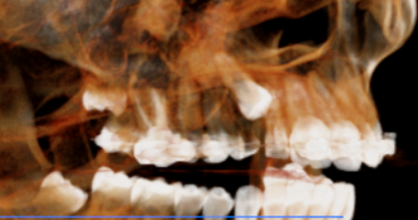
CROSS- SECTIONAL IMAGES

13 REGION | 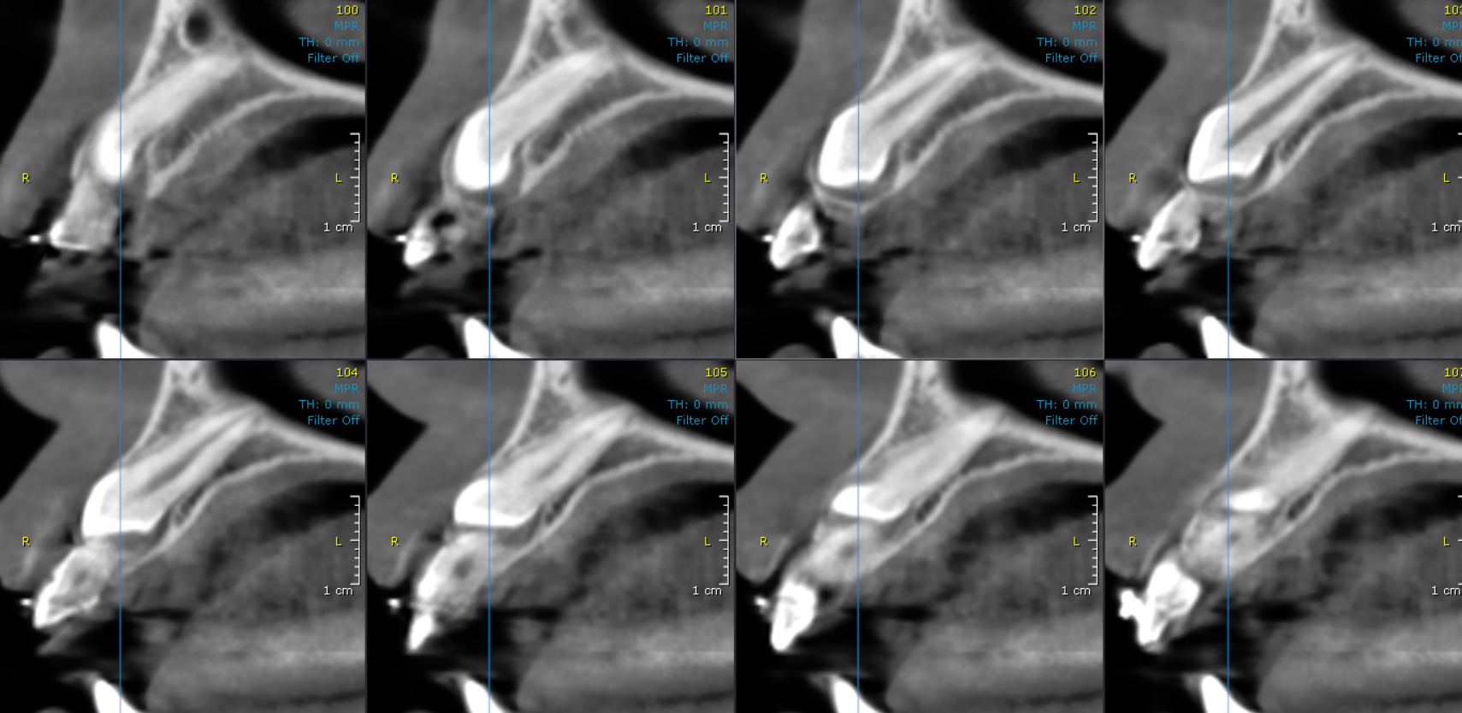
SAGITTAL IMAGES
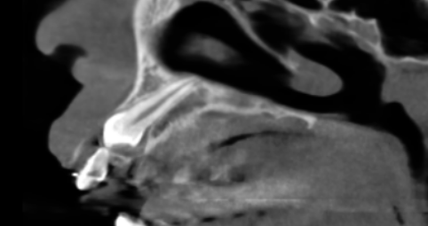

**** End of report ****

